Microbial composition in different metabolic states (Active, aestivation and post-aestivación) of the land invasive snail Cornu aspersum
E. Alejandro Pardo Sarmiento¹ & Luz H. Patiño^{1,2}

¹Departamento de Biología. Escuela de Ciencias e Ingeniería. Universidad del Rosario. Bogotá. Colombia.
²Centro de investigaciones en microbiología y biotecnología de la Universidad del Rosario CIMBIUR, Universidad del Rosario, Bogotá D.C, Colombia.

*Corresponding author:
E.A.P-S. Departamento de Biología. Escuela de Ciencias e Ingeniería. Universidad del Rosario. Cra. 26 #63B-48. Bogotá. Colombia. E-mail: edgara.pardo@urosario.edu.co
Abstract
Survival adaptations shape the internal conditions that may modulate gut microbial composition in invertebrates. Consequently, physiological states can either promote or constrain changes in microbial diversity and function, depending on the strategies employed to cope with adverse environmental conditions. This study aimed to explore the relationship between gut microbiota composition and the phases of aestivation in Cornu aspersum. Individuals were collected and experimentally assigned to active, estivating, and post-estivation states. We observed shifts in microbial abundance and diversity across physiological states, with reduced richness during estivation and increased diversity following post-estivation. Additionally, we identified taxa associated with specific physiological states that may play key metabolic roles. Overall, our findings suggest a relationship between host physiology and gut microbiota in C. aspersum, which may contribute to the species invasiveness and resilience under variable environmental conditions.

Keywords: Physiological states, gut microbiota, Cornu aspersum, aestivation.

Introduction
The gut microbiota—defined as the collection of microorganisms that inhabit the digestive tract of organisms—depends on the survival strategies of its hosts in response to environmental pressures (Wong S, Rawls JF, 2012; Alberdi, A. et al 2016). Among these strategies, physiological adaptations modify the internal conditions that allow the colonization and persistence of microorganisms in the digestive system. For example, factors such as starvation stress and dormancy states can alter the composition of the gut microbiota in invertebrates (Bosmans, L., 2018; Dai, W.-F., et al 2018). However, some physiological adaptations can also stabilize microbial communities, as occurs in crabs exposed to suboptimal temperatures (Ling, Y., et al 2012). Taken together, these findings suggest that physiological changes can both promote and restrict variation in microbial composition in response to fluctuating environmental conditions.
One of the adaptations employed by various invertebrates such as Cornu aspersum, Apostichopus japonicus, and Protopterus sp. (Jiang C., et al., 2023) is estivation. This dormant state allows organisms to survive during periods of high temperatures, drought, and food scarcity (Jiang C. et al., 2023). During estivation, physiological changes occur, including a reduction in metabolic rate (Storey KB & Storey JM., 2012), energy expenditure, heart rate, and respiratory rate (Barnhart MC. & McMahon BR., 1987; Storey KB & Storey JM., 1994), protein synthesis (Pakay JL., 2002), and respiratory acidosis (Barnhart MC. & McMahon BR., 1987). These changes can affect the dynamics of the digestive system, even at the transcriptional level (Tilikj & Novo, 2022), suggesting that estivation can influence the composition of the gut microbiota.
The gut microbiota plays essential roles in metabolism and multiple physiological processes (Alshammary AG. et al., 2024). Gut bacteria have coevolved with their hosts in symbiotic relationships (McFall-Ngai, 2013), providing adaptive advantages throughout the life cycle. For example, these microorganisms facilitate the digestion of complex compounds such as cellulose and lignin in various invertebrates (Martin, 1991; Kim, 2015; Zhang et al., 2022). In this context, a bidirectional relationship between the gut microbiota and the physiological adaptations that allow organisms to cope with environmental changes is plausible.
Studies in physiological states analogous to estivation, such as hibernation or torpor, have demonstrated significant changes in gut microbial communities, associated with both environmental conditions and metabolic modifications in the host (Sonoyama, 2009; Carey et al., 2012, 2013; Zhou, 2022; Liu et al., 2023; Popov et al., 2023). For example, tryptophan-producing bacteria, a molecule potentially involved in sleep and dormancy processes, have been reported in sea cucumbers (Kang et al., 2023). In hibernating snails, bacteria capable of modulating ice nucleus formation have been identified, which could contribute to protection against tissue damage induced by low temperatures (Nicolai, 2005). Furthermore, after periods of dormancy, urease-positive bacteria have been detected that could participate in mitigating the oxidative stress associated with reoxygenation (Speeg & Campbell, 1968).
Despite these advances, the relationship between gut microbiota composition and dormancy states remains largely unexplored, especially in invasive ectothermic invertebrates with high phenotypic plasticity. In particular, how different physiological phases—including estivation and metabolic recovery—influence the structure of microbial communities in an integrated manner is not yet fully understood. This study focuses on exploring the relationship between gut microbiota composition and physiological state in Cornu aspersum. This invasive species, characterized by its high adaptability and wide geographic distribution, is an ideal model for investigating the mechanisms of physiological plasticity and survival strategies in the variable environments characteristic of invasive species.
It is hypothesized that estivation will induce significant changes in intestinal microbial diversity (α and β), with an increase in the abundance of Firmicutes potentially associated with neurotransmitter production during this state, followed by functional recovery in the post-estivation phase (Koleva et al., 2016). At the phylum level, a decrease in the abundance of Campylobacterota, Cyanobacteria, and Patescibacteria, and an increase in Firmicutes, Desulfobacterota, Myxococcota, and Bacteroidetes are expected in estivating individuals. Finally, differences in the abundance of amylolytic, cellulolytic, and proteolytic bacteria are predicted between physiological states, with a higher representation in active individuals, followed by post-estivation individuals, in which feeding activity is restored. This study integrates high-throughput sequencing tools and bioinformatics analysis, exploring the role of the interaction between the gut microbiota and physiological states in the resistance and resilience capacity of Cornu aspersum to environmental variations.
Methodology
Collection and maintenance of snails
Nine adult individuals of Cornu aspersum were collected from urban gardens in Bogotá (4°39'34.6"N 74°07'42.7"W) by hand following rainfall events. Taxonomic identification was carried out following standard morphological descriptions (Chevalier, 1977), considering the light brown coloration and the presence of five dark spiral bands on the shell.
The individuals were transferred to the laboratory and kept under controlled conditions (T=21°C, RH= 60%), in containers with soil substrate. Food was provided ad libitum (carrot, lettuce and calcium carbonate; Fig 1A) and the hydration of the snails was maintained by daily spraying with water.
Physiological states
Individuals were randomly assigned to three experimental groups: active state (n=3), estivation (n=3), and post-estivation (n=3). To maintain the active state, food was renewed every two days, and the organisms were hydrated daily by misting. To induce estivation, food was withdrawn, and the individuals were kept in an incubator at 25 °C. Epiphragm formation was used as an indicator of entry into estivation (Fig 1C).
For the post-estivation group, three estivating individuals were rehydrated by applying water droplets and maintained for 48 hours under active conditions with food provided.
DNA extraction
The individuals were euthanized by immersion in 96% ethanol. Subsequently, soft tissue was extracted by fracturing the shell. Under sterile conditions, the digestive system was extracted from each individual (Fig 1B), and the tissue was immediately stored at −30 °C until processing.
DNA extraction was performed using the Stool DNA Kit (Qiagen), following the manufacturer's instructions. DNA concentration and purity were assessed by spectrophotometry (NanoDrop 2000, Thermo Fisher Scientific), and its integrity was verified by electrophoresis on a 2% agarose gel.
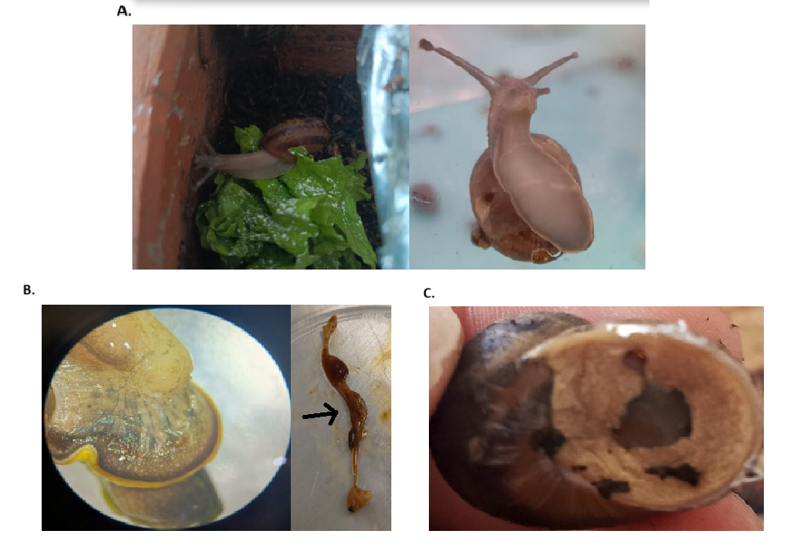
Fig 1. Morphology and physiological states of Cornu aspersum. A. Adult C. aspersum individual. B. Soft tissue obtained after dissection; the arrow indicates the portion of the digestive system extracted for analysis. C. Formation of the epiphragm during estivation.

PCR amplification
One sample for each physiological state was chosen based on the highest DNA concentration and the 260/280 ratio (Table S1). Therefore, the amplified samples correspond to A3, B2, and C1 (Fig S1).
The 16S rRNA gene region was amplified using the primers 27F-AGAGTTTGATCCTGGCTCAG and 1492R-GGTTACCTTGTTACGACTT (Huttenhower C., et al. 2012).
The PCR conditions consisted of an initial denaturation of 15 minutes at 96 °C, followed by 35 cycles of 96 °C for 30 s, 52 °C for 30 s, and 72 °C for 1 min, with a final extension of 10 minutes at 72 °C.
Amplification was performed using Phusion High-Fidelity PCR Master Mix reagent (New England Biolabs). The quality and integrity of the amplicons were verified by electrophoresis on a 2% agarose gel (Fig S2).
Nanopore Sequencing
A representative amplicon was selected for sequencing from each physiological state (Fig S2). Libraries were prepared using the Ligation Sequencing Kit (Oxford Nanopore Technologies), following the manufacturer's instructions. PCR products were barcoded (EXP-NBD196) and adapters were subsequently ligated using the NEBNext Quick Ligation Module.
The final library was loaded into an R10 flow cell (FLO-MIN106) and sequenced using the MinION Mk1C device with MinKNOW software (Oxford Nanopore Technologies). Basecalling was performed automatically.
Bioinformatic processing
The quality of the FASTQ reads was assessed using NanoStat and NanoPlot, analyzing the length distribution and sequence quality scores. Taxonomic classification was performed using Kraken 2, employing a custom database constructed from standard databases and PlusPF. The results were visualized using the Pavian platform, and the taxonomic classification table and the abundance and taxonomic assignment table were exported for subsequent statistical analysis.
Data analysis
Statistical analysis was performed in R. Relative abundances of bacterial taxa and alpha diversity indices (Shannon and Simpson) were calculated using the vegan package (v2.6-4; Oksanen et al., 2022).
To assess differences in microbial composition between physiological states, a centered log-ratio transformation (CLR) was applied to the abundance data, followed by principal component analysis (PCA) using the compositions package (v2.0-6).
Finally, a microbial co-occurrence network based on Spearman correlations was constructed, applying multiple comparisons correction using the Benjamini–Hochberg method (q<0.05) with the igraph package (v1.3.5). This analysis allowed for the evaluation of potential interactions between bacterial taxa in the different physiological states.
Permits statement
No permits were required for sample collection, as all specimens were obtained from public urban gardens. Additionally, no specific authorization was necessary for the handling of Cornu aspersum due to its status as an invasive species in Colombia.
All procedures were conducted in accordance with the ethical standards established by Colombian legislation, specifically Law 84 of 1989.
Results
Taxonomic composition of the intestinal microbiota in Cornu aspersum
The abundance of bacteria, at both the phylum and family levels, varied according to the physiological state (Active, Estivation, Post-estivation) of Cornu aspersum. The five most abundant bacterial phyla identified in this study were Bacteroidetes, Firmicutes, Proteobacteria, Tenericutes, and Actinobacteria (sequence count >100; Fig. 2A). At the family level, the most representative were Prevotellaceae, Mycoplasmataceae, Veillonellaceae, Enterobacteriaceae, and Peptostreptococcaceae (Fig. 2B).
Variations in the relative abundance of taxa were observed among the different physiological states. The active state showed the highest total abundance of bacteria, at both the phylum and family levels (Fig. 2C). In this state, the phyla Bacteroidetes, Firmicutes, and Omnitrophota showed greater relative abundance compared to the estivation and post-estivation states. At the family level, the active state showed a greater number of dominant taxa compared to the other states (Fig. 2E).
When comparing the taxonomic profiles, it was observed that Bacteroidetes, Firmicutes, Proteobacteria, and Actinobacteria predominated in the active and post-estivation states (Fig. 2F). In contrast, Proteobacteria and Tenericutes predominated during estivation. At the family level, the active state was characterized by a greater abundance of Prevotellaceae, Veillonellaceae, Peptostreptococcaceae, and Ruminococcaceae (Fig. 2G), while Mycoplasmataceae and Enterobacteriaceae stood out during estivation. In post-estivation, a greater abundance of Enterobacteriaceae, Burkholderiaceae, and Propionibacteriaceae was observed.

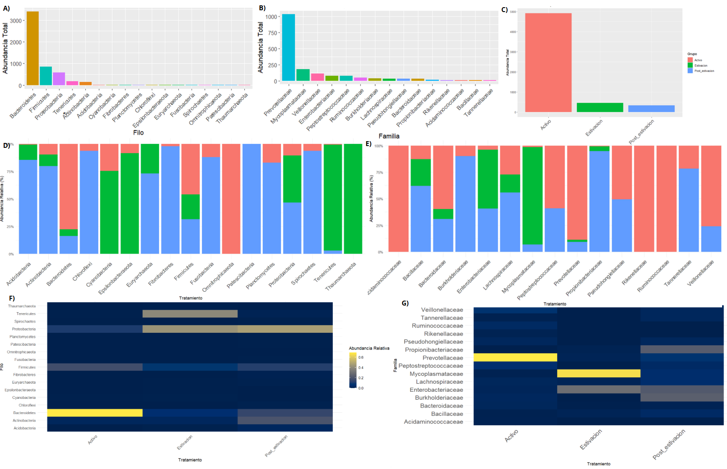
Fig 2 – Abundancias totales y relativas de los diferentes taxones encontrados en estados fisiológicos de Cornu Aspersum. A) Abundancia total de los filos encontrados. B) Abundancia total de las familias encontradas. Se presentan las 15 familias con mayor abundancia total. C) Comparación de abundancias de todos los filos teniendo en cuenta el estado de estivación. D). Abundancia relativa por cada filo bacteriano en los estados fisiológicos E) Abundancia relativa por cada familia bacteriana en los estados fisiológicos. Se presentan las 15 familias con mayor abundancia total. N=3. F). Abundancia relativa de los filos en cada estado fisiológico. G) Abundancia relativa de los filos en cada estado fisiológico. Se presentan las 15 familias con mayor abundancia total. N=3.

The Alpha and beta diversity of bacteria changes depending on the estivation state.
Differences in microbial diversity were observed among the physiological states (Table 1). In terms of species richness, the active state had the highest number of taxa, followed by the post-estivation state, while the estivation state showed the lowest richness. The active state had a richness 3.6 times greater than the estivation state and 2.3 times greater than the post-estivation state.
However, the alpha diversity indices (Shannon and Simpson) showed a different pattern: the greatest diversity was observed in the post-estivation state, followed by the active state. Specifically, Shannon's diversity was approximately 2.3 times greater and Simpson's diversity 1.4 times greater in post-estivation compared to estivation.
Regarding beta diversity, differences in microbial composition were evident among the three physiological states (Fig. 3A). The greatest dissimilarity was observed between the active and estivation states, while the difference between the active and post-estivation states was smaller.
Principal component analysis (PCA) identified the taxa that contributed to the separation between states, including Prevotellaceae, Veillonellaceae, and Peptostreptococcaceae (Table 2), revealing differences in taxonomic groupings according to physiological state (Fig. 3B).
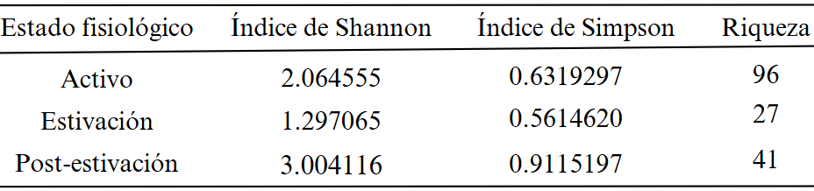
Tabla 1 – Diversidad Alpha para los estados fisiológicos de Cornu Aspersum. Se presentan los índices de Shannon, Simpson y la riqueza de especies en los estados fisiológicos activo, Estivación y post-estivación. n=1.

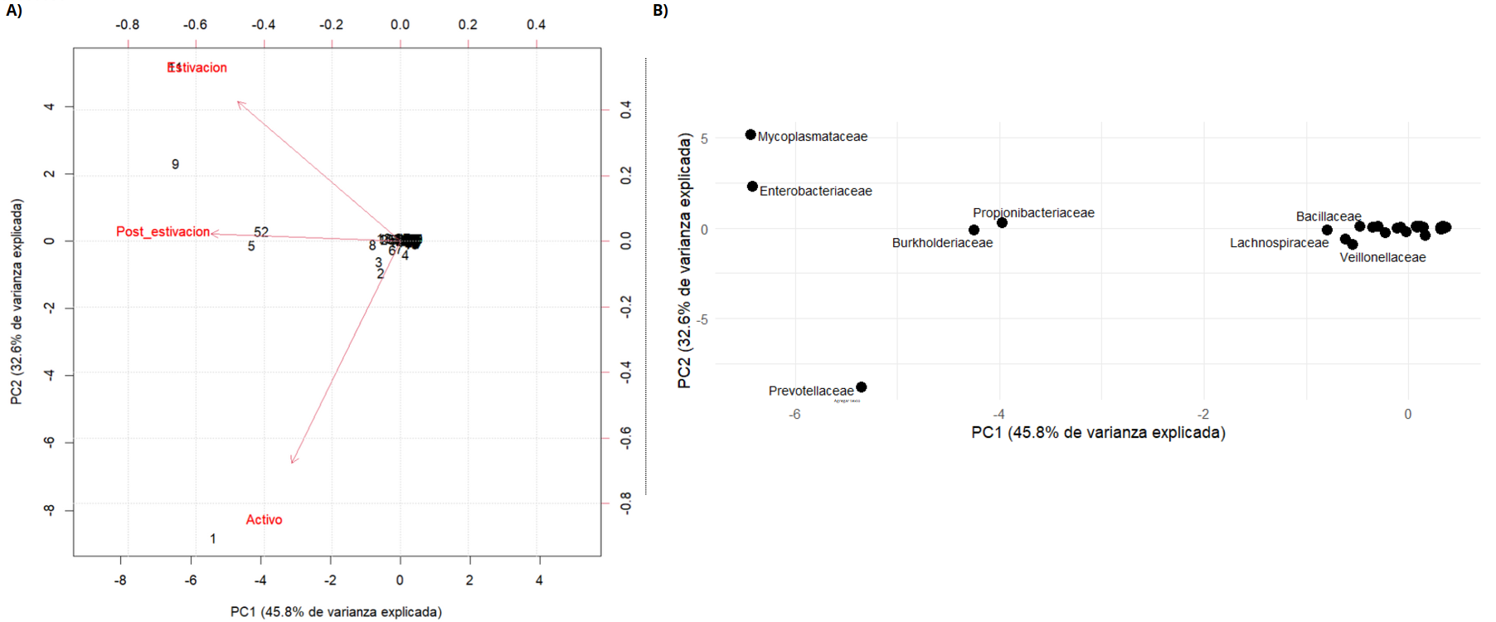
Fig 3 – Análisis de componentes principales de estados fisiológicos de Cornu aspersum. A) biplot escalado de diversidad Beta para los estados activo, estivación y post-estivación. Los números representan las diferentes familias de bacterias presentada. B) Biplot con el nombre y posición de bacterias correspondientes a los números presentados en A. N=3.

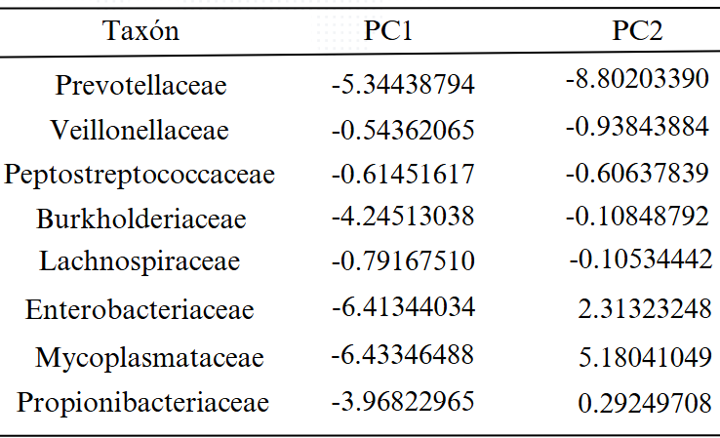
Tabla 2 – taxones más influyentes en la diversidad Beta. Se presentan los taxones que más influyen en el componente 1 y 2 del PCA realizado para observar la diversidad Beta. N=3.

Microbial Co-occurrence Networks
Differences were observed in the structure of co-occurrence networks between physiological states. The active state exhibited a complex network, with a greater number of interactions between taxa (Fig. 4). In contrast, the estivation state showed a more simplified network, characterized by lower connectivity.
The post-estivation state presented an intermediate pattern, with greater structural similarity to the active state than to the estivation state. Interestingly, no direct connections were observed between the nodes corresponding to estivation and post-estivation, suggesting a reorganization of microbial interactions during the transition between these states.

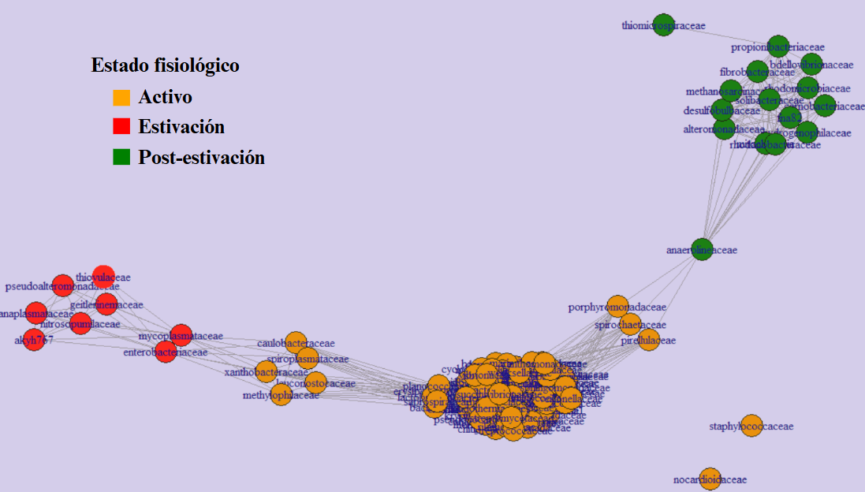
Fig 4 – Red microbiana de los estados fisiológicos de Cornu Aspersum. Los nodos representan los diferentes taxones (familias) encontradas en los estados fisiológicos de Cornu Aspersum. Las líneas representan las conexiones de relación y cercanía entre los diferentes taxones. N=3

Discussion
In invertebrates, the relationship between the gut microbiota and animal physiology is essential in the face of environmental variation. The specific physiological adaptations of each limiting species can differentially modulate the gut microbial composition and its metabolic functions. In this study, we analyzed the gut microbiota of Cornu aspersum in three physiological states (active, estivation, and post-estivation), revealing marked changes in its structure and organization. Our results showed that the active state is associated with greater microbial abundance and complexity, while estivation leads to a reduction in both the abundance and connectivity of bacterial communities. In contrast, the post-estivation state showed a partial recovery of diversity, characterized by greater uniformity in the distribution of taxa.
The gut microbiota plays key roles in host metabolism, including the degradation of complex dietary compounds (Brune & Ohkuma, 2010), the regulation of the immune system (Atarashi et al., 2011), and the modulation of other microorganisms. In this context, the greater abundance and richness of bacteria observed in active individuals is consistent with previous studies in mollusks, where nutrient availability in active snails favors the abundance and diversity of bacterial communities (Koleva et al., 2012). Similarly, studies in hibernating amphibians have reported similar findings, which coincide with our results during estivation (Tong et al., 2023). Furthermore, studies in bees have shown an increase in microbial diversity after hibernation (Bosmans et al., 2018), consistent with the increase observed in the post-estivation phase.
The role of diet is central to the structuring of the gut microbiota. In our study, active individuals consumed a high-fiber diet (lettuce), which likely favored the abundance of taxa such as Prevotellaceae, associated with the degradation of complex polysaccharides. Fiber acts as a prebiotic, promoting microbial abundance and diversity (Jovanovic-Malinovska et al., 2014). In contrast, the absence of food during estivation eliminates energy sources (Cramp, 2009) and inhibits digestive processes (Tilikj & Novo, 2022), creating a less favorable environment for microorganisms, resulting in decreased bacterial abundance and diversity. Interestingly, the post-estivation state exhibited greater microbial diversity than the active state. This pattern could be explained by metabolic reactivation after prolonged fasting, which restores resources and generates new ecological niches that favor microbial diversification.
Analysis of specific taxa provides evidence regarding possible functions associated with each physiological state. The abundance of Prevotellacea in active individuals is associated with diets rich in carbohydrates and fiber, due to its ability to degrade complex polysaccharides (Precup, G., & Vodnar DC., 2019; Tett, A., et al., 2021). Likewise, members of Mycoplasmataceae, such as Ureaplasma and Mycoplasma, are identified as potentially involved in nitrogen metabolism (Swanson, M. T., et al., 2022). Ureaplasma participates in the hydrolysis of urea (Smith, D. G., 1993), producing ammonia that can be reused in amino acid synthesis (Stewart, G. S., & Smith, C. P., 2005). For its part, Mycoplasma could contribute to immunological tolerance by decreasing cellular activity and the humoral response during the accumulation of toxic products, reducing energy expenditure, and inhibiting digestive processes that occur during estivation (Adegboye, D. S., 1978). Furthermore, Enterobacteriaceae taxa, such as E. coli, may participate in vitamin synthesis, the maintenance of anaerobic conditions, and the regulation of other microbial populations (Moreira de Gouveia, 2024).
Bacteria belonging to the Propionibacteriaceae family were also influential in the microbial diversity of the post-estivation state. These bacteria may play a fundamental role in restoring intestinal balance, allowing the growth of bifidobacteria (Bouglé, D., et al., 1999) and contributing to the production of essential vitamins such as vitamin B12 (Piwowarek, K., et al., 2018). Furthermore, the production of bacteriocins by these bacteria and members of Burkholderiaceae could limit the growth of pathogenic microorganisms (Lyon et al., 1993; Depoorter et al., 2016). Additionally, Burkholderiaceae could contribute to the detoxification of compounds generated during estivation, promoting metabolic recovery (Grove, 2010).
This study has significant limitations, including the small sample size (N=3) and the lack of control for variables such as age. Although adult snails were selected, their age was not considered, which could influence bacterial diversity and abundance. Furthermore, while the taxonomic analysis provides structural information, it does not allow for direct inferences about the metabolic functions of the gut microbiota, highlighting the need to integrate multi-omics approaches using metabolomics tools to further investigate functional microbiota-host interactions.
This study has characterized and compared the gut microbiota of C. aspersum during different physiological states, offering valuable insights into how physiological adaptations interact with the gut microbiota. Our exploratory approach suggests that dormancy states associated with extreme metabolic changes, such as estivation, could affect the microbial composition of C. aspersum. This interaction between physiology and microbiota could constitute a key mechanism in the phenotypic plasticity and ecological resilience of the species, allowing these organisms to expand and invade new ecosystems with fluctuating environmental variables. To validate the patterns found in this study, it is essential to conduct replicates with larger sample sizes and delve deeper into the ecological and functional relationships of the gut microbiota of C. aspersum using complementary metabolomic approaches.
References
Adegboye, D. S. (1978). A review of mycoplasma-induced immunosuppression. The British Veterinary Journal, 134(6), 556–560. https://doi.org/10.1016/s0007-1935(17)33337-7
Alberdi, A., Aizpurua, O., Bohmann, K., Zepeda-Mendoza, M. L., & Gilbert, M. T. P. (2016). Do vertebrate gut metagenomes confer rapid ecological adaptation? Trends in Ecology & Evolution, 31(9), 689–699. https://doi.org/10.1016/j.tree.2016.06.008
Alshammary, A. G., Rajab, J. M., & Alshammary, R. A. A. (2024). The role of Microbiota in animal physiology: An integrative review. Al-Salam Journal for Medical Science, 3(2), 53–61. https://doi.org/10.55145/ajbms.2024.03.02.08
Atarashi, K., Tanoue, T., Shima, T., Imaoka, A., Kuwahara, T., Momose, Y., Cheng, G., Yamasaki, S., Saito, T., Ohba, Y., Taniguchi, T., Takeda, K., Hori, S., Ivanov, I. I., Umesaki, Y., Itoh, K., & Honda, K. (2011). Induction of colonic regulatory T cells by indigenous Clostridium species. Science (New York, N.Y.), 331(6015), 337–341. https://doi.org/10.1126/science.1198469
Barnhart, M. C., & McMahon, B. R. (1987). Discontinuous carbon dioxide release and metabolic depression in dormant land snails. The Journal of Experimental Biology, 128(1), 123–138. https://doi.org/10.1242/jeb.128.1.123
Bosmans, L., Pozo, M. I., Verreth, C., Crauwels, S., Wäckers, F., Jacquemyn, H., & Lievens, B. (2018). Hibernation leads to altered gut communities in bumblebee queens (Bombus terrestris). Insects, 9(4), 188. https://doi.org/10.3390/insects9040188
Bouglé, D., Roland, N., Lebeurrier, F., & Arhan, P. (1999). Effect of propionibacteria supplementation on fecal bifidobacteria and segmental colonic transit time in healthy human subjects. Scandinavian Journal of Gastroenterology, 34(2), 144–148. https://doi.org/10.1080/00365529950172998
Brune, A. (2010). Methanogens in the Digestive Tract of Termites. En (Endo)symbiotic Methanogenic Archaea (pp. 81–100). Springer Berlin Heidelberg.
Carey, H. V., & Duddleston, K. N. (2014). Animal-microbial symbioses in changing environments. Journal of Thermal Biology, 44, 78–84. https://doi.org/10.1016/j.jtherbio.2014.02.015
Carey, H. V., Walters, W. A., & Knight, R. (2013). Seasonal restructuring of the ground squirrel gut microbiota over the annual hibernation cycle. American Journal of Physiology. Regulatory, Integrative and Comparative Physiology, 304(1), R33-42. https://doi.org/10.1152/ajpregu.00387.2012
Cramp, R. L., Kayes, S. M., Meyer, E. A., & Franklin, C. E. (2009). Ups and downs of intestinal function with prolonged fasting during aestivation in the burrowing frog, Cyclorana alboguttata. The Journal of Experimental Biology, 212(Pt 22), 3656–3663. https://doi.org/10.1242/jeb.027748
Dai, W.-F., Zhang, J.-J., Qiu, Q.-F., Chen, J., Yang, W., Ni, S., & Xiong, J.-B. (2018). Starvation stress affects the interplay among shrimp gut microbiota, digestion and immune activities. Fish & shellfish immunology, 80, 191–199. https://doi.org/10.1016/j.fsi.2018.05.040
Depoorter, E., Bull, M. J., Peeters, C., Coenye, T., Vandamme, P., & Mahenthiralingam, E. (2016). Burkholderia: an update on taxonomy and biotechnological potential as antibiotic producers. Applied Microbiology and Biotechnology, 100(12), 5215–5229. https://doi.org/10.1007/s00253-016-7520-x
Grove, A. (2010). Urate-responsive MarR homologs from Burkholderia. Molecular bioSystems, 6(11), 2133–2142. https://doi.org/10.1039/c0mb00086h
Huang, Y., Tang, J., Cai, Z., Qi, Y., Jiang, S., Ma, T., Yue, Y., Huang, F., Yang, H., & Ma, Y. (2023). Alterations in the intestinal microbiota associated with active tuberculosis and latent tuberculosis infection. Heliyon, 9(11), e22124. https://doi.org/10.1016/j.heliyon.2023.e22124
Jandhyala, S. M., Talukdar, R., Subramanyam, C., Vuyyuru, H., Sasikala, M., & Nageshwar Reddy, D. (2015). Role of the normal gut microbiota. World Journal of Gastroenterology: WJG, 21(29), 8787–8803. https://doi.org/10.3748/wjg.v21.i29.8787
Jiang, C., Storey, K. B., Yang, H., & Sun, L. (2023). Aestivation in nature: Physiological strategies and evolutionary adaptations in hypometabolic states. International Journal of Molecular Sciences, 24(18), 14093. https://doi.org/10.3390/ijms241814093
Jovanovic-Malinovska, R., Kuzmanova, S., & Winkelhausen, E. (2014). Oligosaccharide profile in fruits and vegetables as sources of prebiotics and functional foods. International Journal of Food Properties, 17(5), 949–965. https://doi.org/10.1080/10942912.2012.680221
Kim, J. Y., Yoon, S. M., & Kim, Y.-S. (2015). Cellulase Activity of Symbiotic Bacteria from Snails, Achatina fulica. Journal of the Korean Wood Science and Technology, 43(5), 628–640. https://doi.org/10.5658/wood.2015.43.5.628
Koleva, Z. V., Kizheva, Y. K., Tishkov, S. H., Dedov, I. K., Kirova, E. L., Stefanova, P. M., Moncheva, P. A., & Hristova, P. K. (2015). Dynamics of bacterial community in the gut of Cornu aspersum. Journal of BioScience & Biotechnology, 4(3).
Ling, Y., Xu, P., Afiqah-Aleng, N., Ishak, S. D., Wang, Y., Shu-Chien, A. C., Sung, Y. Y., Rozaimi, R., Liew, H. J., Fazhan, H., & Waiho, K. (2024a). Physiological adaptation and gut microbiota changes of orange mud crab Scylla olivacea in response to increased temperature condition. Aquatic Sciences, 86(4). https://doi.org/10.1007/s00027-024-01120-8
Liu, H., Li, J., Zhou, D., Cai, W., Rehman, M., Feng, Y., Kong, Y., Liu, X., Fahad, S., & Deng, G. (2023). Impact of dormancy periods on some physiological and biochemical indices of potato tubers. PeerJ, 11, e15923. https://doi.org/10.7717/peerj.15923
Lyon, W. J., Sethi, J. K., & Glatz, B. A. (1993). Inhibition of psychrotrophic organisms by propionicin PLG-1, a bacteriocin produced by Propionibacterium thoenii. Journal of Dairy Science, 76(6), 1506–1513. https://doi.org/10.3168/jds.S0022-0302(93)77482-2
Martin, M. M., Jones, C. G., & Bernays, E. A. (1991). The evolution of cellulose digestion in insects. Philosophical Transactions of the Royal Society of London. Series B, Biological Sciences, 333(1267), 281–288. https://doi.org/10.1098/rstb.1991.0078
McFall-Ngai, M., Hadfield, M. G., Bosch, T. C. G., Carey, H. V., Domazet-Lošo, T., Douglas, A. E., Dubilier, N., Eberl, G., Fukami, T., Gilbert, S. F., Hentschel, U., King, N., Kjelleberg, S., Knoll, A. H., Kremer, N., Mazmanian, S. K., Metcalf, J. L., Nealson, K., Pierce, N. E., … Wernegreen, J. J. (2013). Animals in a bacterial world, a new imperative for the life sciences. Proceedings of the National Academy of Sciences of the United States of America, 110(9), 3229–3236. https://doi.org/10.1073/pnas.121852511
Moreira de Gouveia, M. I., Bernalier-Donadille, A., & Jubelin, G. (2024). Enterobacteriaceae in the human gut: Dynamics and ecological roles in health and disease. Biology, 13(3), 142. https://doi.org/10.3390/biology13030142
Pakay, J. L., Withers, P. C., Hobbs, A. A., & Guppy, M. (2002). In vivo downregulation of protein synthesis in the snail Helix apersa during estivation. American Journal of Physiology. Regulatory, Integrative and Comparative Physiology, 283(1), R197-204. https://doi.org/10.1152/ajpregu.00636.2001
Piwowarek, K., Lipińska, E., Hać-Szymańczuk, E., Kieliszek, M., & Ścibisz, I. (2018). Propionibacterium spp.-source of propionic acid, vitamin B12, and other metabolites important for the industry. Applied Microbiology and Biotechnology, 102(2), 515–538. https://doi.org/10.1007/s00253-017-8616-7
Precup, G., & Vodnar, D.-C. (2019). Gut Prevotella as a possible biomarker of diet and its eubiotic versus dysbiotic roles: a comprehensive literature review. The British Journal of Nutrition, 122(2), 131–140. https://doi.org/10.1017/S0007114519000680
Smith, D. G., Russell, W. C., Ingledew, W. J., & Thirkell, D. (1993). Hydrolysis of urea by Ureaplasma urealyticum generates a transmembrane potential with resultant ATP synthesis. Journal of Bacteriology, 175(11), 3253–3258. https://doi.org/10.1128/jb.175.11.3253-3258.1993
Sonoyama, K., Fujiwara, R., Takemura, N., Ogasawara, T., Watanabe, J., Ito, H., & Morita, T. (2009). Response of gut microbiota to fasting and hibernation in Syrian hamsters. Applied and Environmental Microbiology, 75(20), 6451–6456. https://doi.org/10.1128/AEM.00692-09
Speeg, K. V., Jr, & Campbell, J. W. (1968). Formation and volatilization of ammonia gas by terrestrial snails. The American Journal of Physiology, 214(6), 1392–1402. https://doi.org/10.1152/ajplegacy.1968.214.6.1392
Stewart, G. S., & Smith, C. P. (2005). Urea nitrogen salvage mechanisms and their relevance to ruminants, non-ruminants and man. Nutrition Research Reviews, 18(1), 49–62. https://doi.org/10.1079/NRR200498
Storey, K. B., & Storey, J. M. (2012). Aestivation: signaling and hypometabolism. The Journal of Experimental Biology, 215(Pt 9), 1425–1433. https://doi.org/10.1242/jeb.054403
Swanson, M. T., Henson, M. W., Handika, H., Achmadi, A. S., Anita, S., Rowe, K. C., & Esselstyn, J. A. (2022). Mycoplasmataceae dominate microbial community differences between gut regions in mammals with a simple gut architecture. Journal of Mammalogy, 104(1), 146–158. https://doi.org/10.1093/jmammal/gyac098
Tett, A., Pasolli, E., Masetti, G., Ercolini, D., & Segata, N. (2021). Prevotella diversity, niches and interactions with the human host. Nature Reviews. Microbiology, 19(9), 585–599. https://doi.org/10.1038/s41579-021-00559-y
Tilikj, N., & Novo, M. (2022). How to resist soil desiccation: Transcriptional changes in a Mediterranean earthworm during aestivation. Comparative Biochemistry and Physiology. Part A, Molecular & Integrative Physiology, 264(111112), 111112. https://doi.org/10.1016/j.cbpa.2021.111112
Tong, Q., Dong, W.-J., Xu, M., Hu, Z.-F., Guo, P., Han, X.-Y., & Cui, L.-Y. (2023). Characteristics and a comparison of the gut microbiota in two frog species at the beginning and end of hibernation. Frontiers in Microbiology, 14, 1057398. https://doi.org/10.3389/fmicb.2023.1057398
Wickham, H., Averick, M., Bryan, J., Chang, W., McGowan, L., François, R., Grolemund, G., Hayes, A., Henry, L., Hester, J., Kuhn, M., Pedersen, T., Miller, E., Bache, S., Müller, K., Ooms, J., Robinson, D., Seidel, D., Spinu, V., … Yutani, H. (2019). Welcome to the tidyverse. Journal of open source software, 4(43), 1686. https://doi.org/10.21105/joss.01686
Wong, S., & Rawls, J. F. (2012). Intestinal microbiota composition in fishes is influenced by host ecology and environment. Molecular Ecology, 21(13), 3100–3102. https://doi.org/10.1111/j.1365-294x.2012.05646.x
Zhang, L., Zhuang, T., Hu, M., Liu, S., Wu, D., & Ji, B. (2022). Gut microbiota contributes to lignocellulose deconstruction and nitrogen fixation of the larva of Apriona swainsoni. Frontiers in Physiology, 13, 1072893. https://doi.org/10.3389/fphys.2022.1072893
Zhou, J., Zhang, R., Guo, P., Li, P., Huang, X., Wei, Y., Yang, C., Zhou, J., Yang, T., Liu, Y., & Shi, S. (2022). Effects of intestinal microbiota on pharmacokinetics of cyclosporine a in rats. Frontiers in Microbiology, 13, 1032290. https://doi.org/10.3389/fmicb.2022.1032290

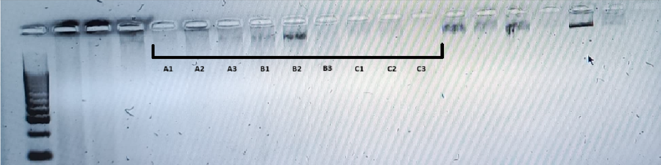
Supplementary Data

Fig S1 – Evaluation of DNA integrity by gel electrophoresis. Lanes labeled A correspond to the active state, B to the post-estivation state, and C to the estivation state. A 100-base-pair molecular weight marker was used as a reference. No defined DNA bands were observed in any of the samples. Although a faint signal was seen in sample B2, a smearing pattern predominated in all lanes, suggesting low DNA concentration and/or degradation of the genetic material.

Table S1 – Quantification of DNA obtained from samples.
Sample | DNA (ng/uL) | A260 (abs) | A280 (abs) | 260/280 | 260/230
A1 | 40.3 | 0.806 | 0.401 | 1.97 | 0.78
A2 | 26.8 | 0.535 | 0.290 | 1.85 | 0.56
A3 | 52.9 | 1.058 | 0.520 | 2.03 | 0.92
B1 | 27.6 | 0.553 | 0.284 | 1.94 | 0.66
B2 | 45.1 | 0.901 | 0.469 | 1.92 | 0.77
B3 | 44.5 | 0.890 | 0.466 | 1.91 | 0.91
C1 | 39.6 | 0.792 | 0.504 | 1.57 | 0.39
C2 | 23 | 0.460 | 0.257 | 1.79 | 0.58
C3 | 34.5 | 0.691 | 0.518 | 1.33 | 0.30
We observed the presence of DNA in all samples, ranging from 23 to 52.9 ng/uL. The 260/280 ratio was within the optimal range (1.8–2) for all samples. In contrast, the 160/230 ratio was less than 1, indicating the presence of contaminants such as phenols, salts, or other tissue-derived compounds. abs: absorbance.

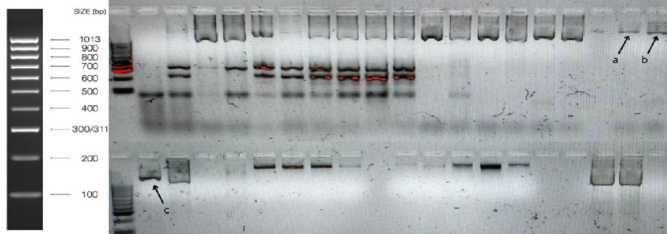
Fig. S2 – Integrity of the amplicon obtained after amplification of the 16S rRNA gene. Bands corresponding to the 16S rRNA gene amplicon were obtained for one DNA sample from each physiological state: a (active), b (post-estivation), and c (estivation). Samples a and b showed clear bands. Sample c showed the presence of the amplicon, although with a smearing pattern. The amplicon size was estimated to be over 1000 base pairs, consistent with the expected region of the 16S rRNA gene (1500 bp). Although the electrophoretic run conditions or the quality of the reagents may have influenced the resolution of the bands, the clear detection of the amplicon in all three samples allowed the sequencing process to continue.

